**DBMS ASSIGNMENT 2**

**CLASS: TE B**

**ROLL NO: 322008**

**Problem Statement:** Design and Develop SQL DDL statements which demonstrate the use of SQL objects such as Table, View, Index, Sequence, Synonym.

**Screenshots:**

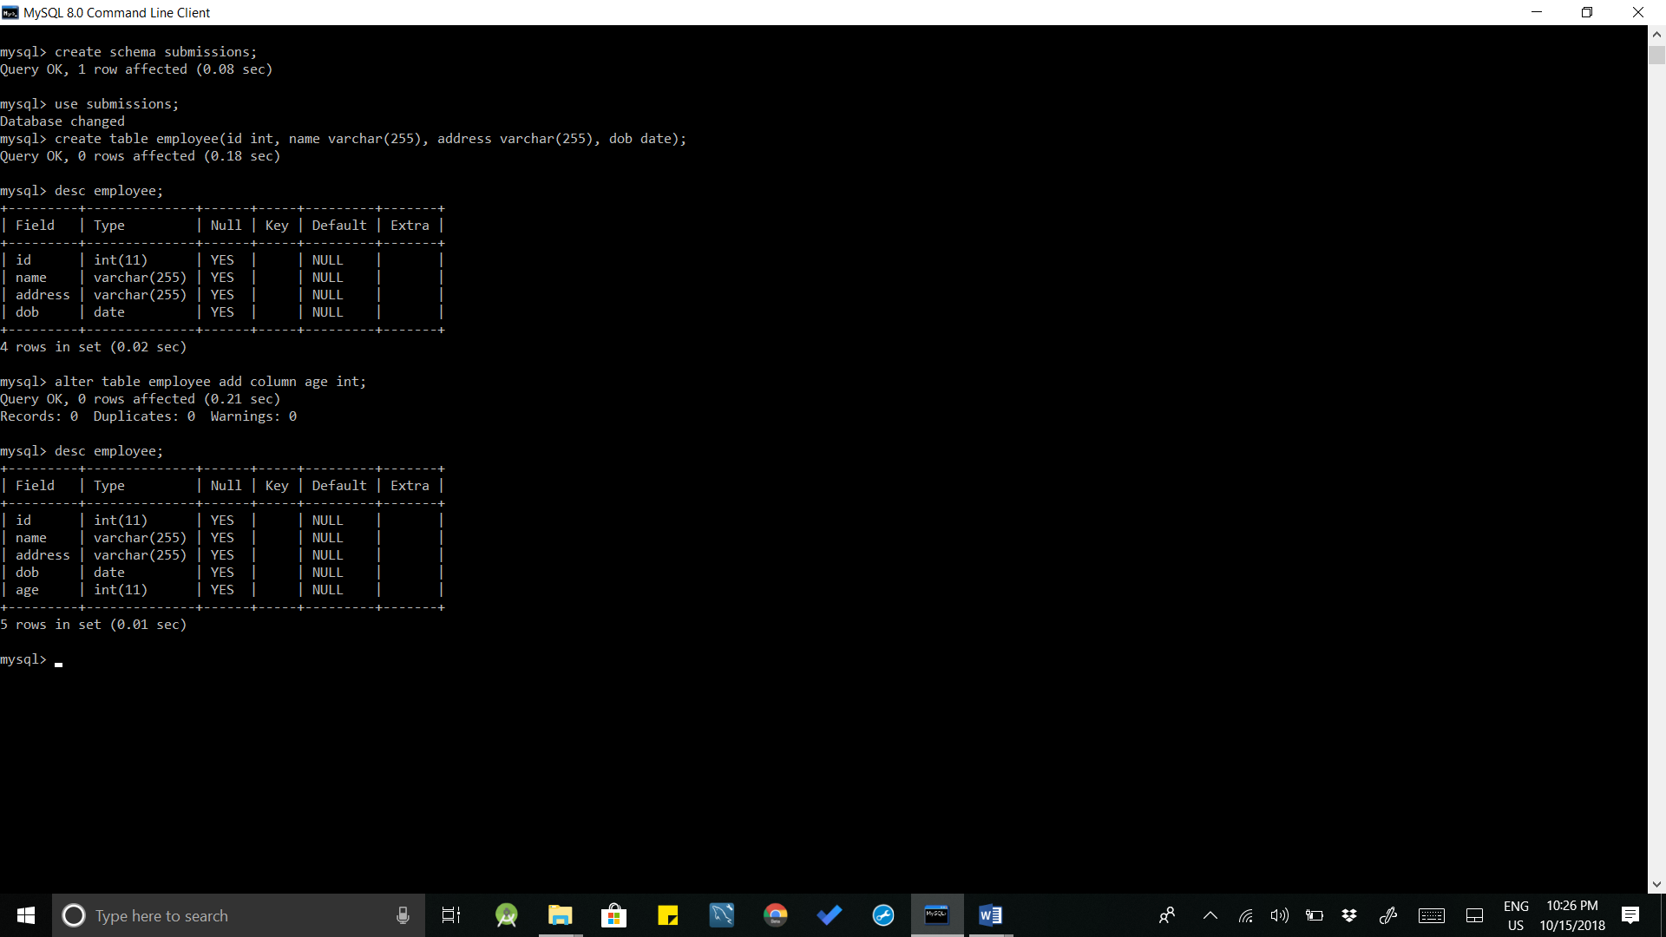

**Queries:**

1. Create schema submissions;
2. Use submissions;
3. Create table employee(id int, name varchar(255), address varchar(255), dob date)
4. Desc employee;
5. Alter table employee add column age int;

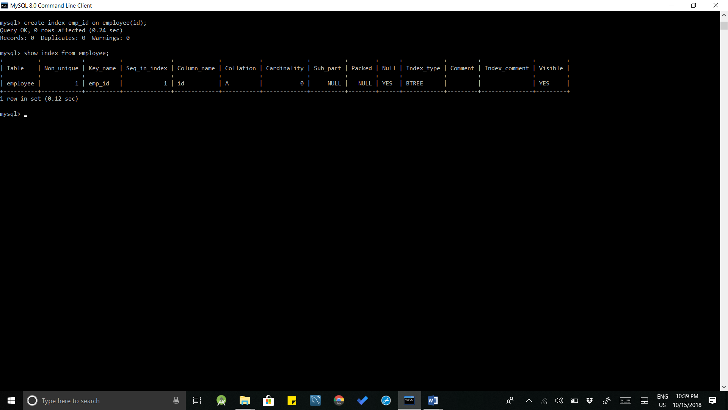

**Queries:**

1. Create index emp_id on employee(id);
2. Show index from employee;

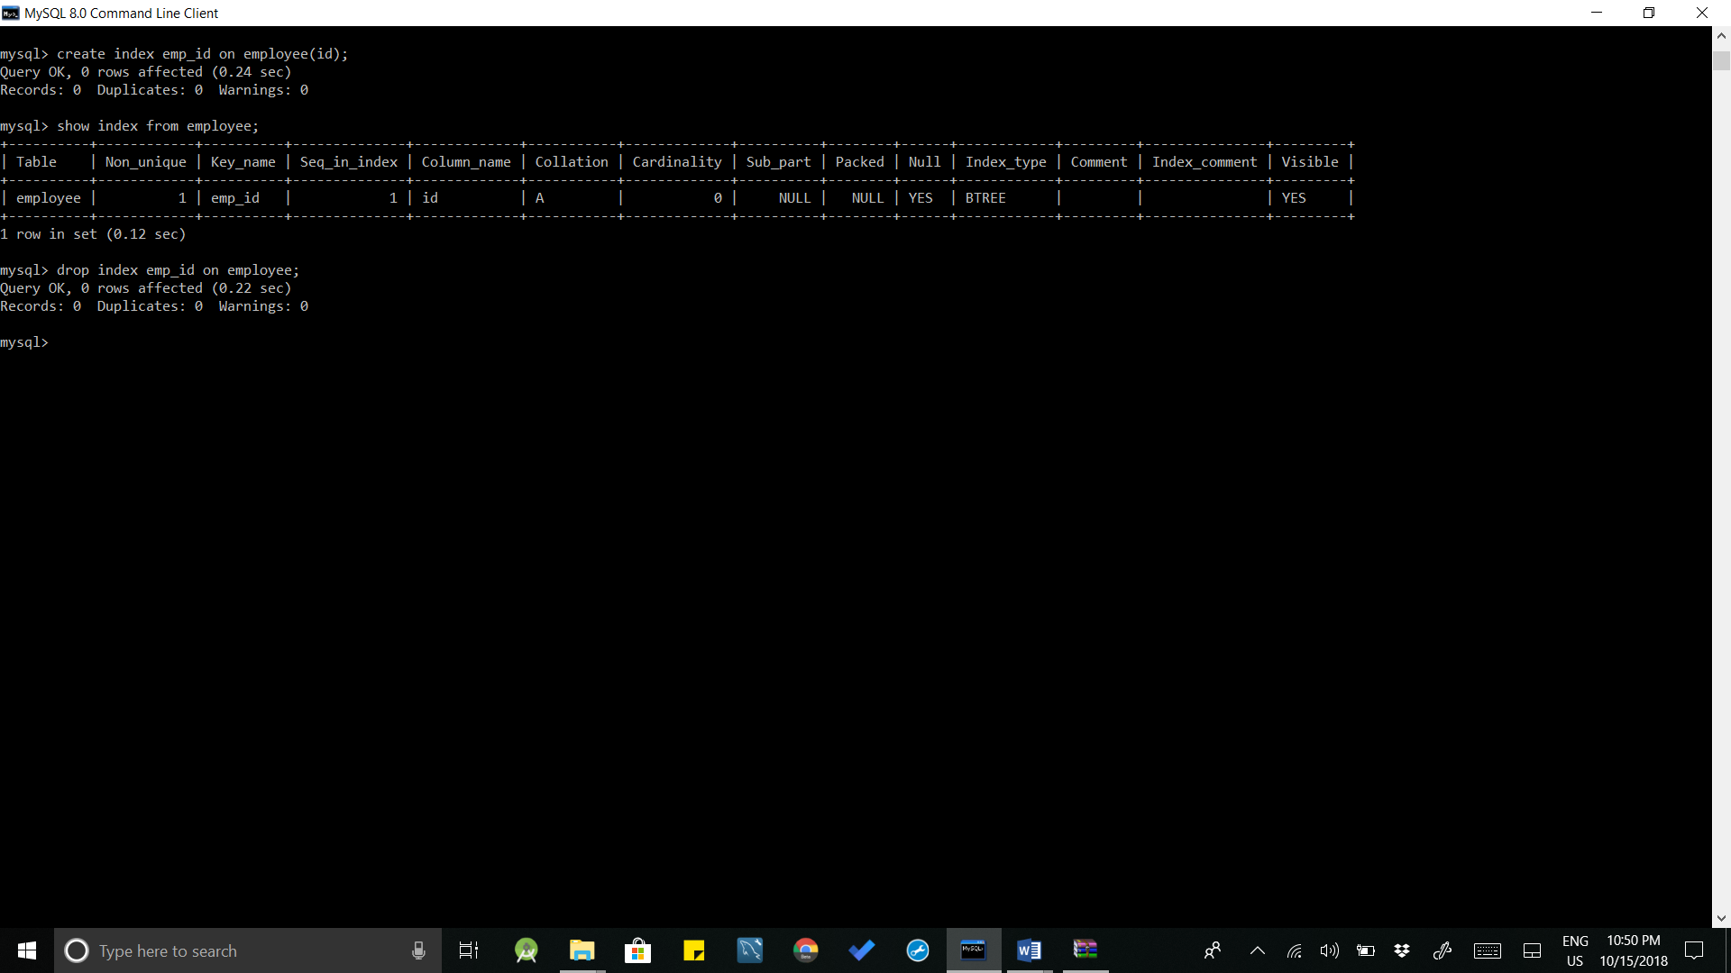

**Queries:**

1. Drop index emp_id on employee;

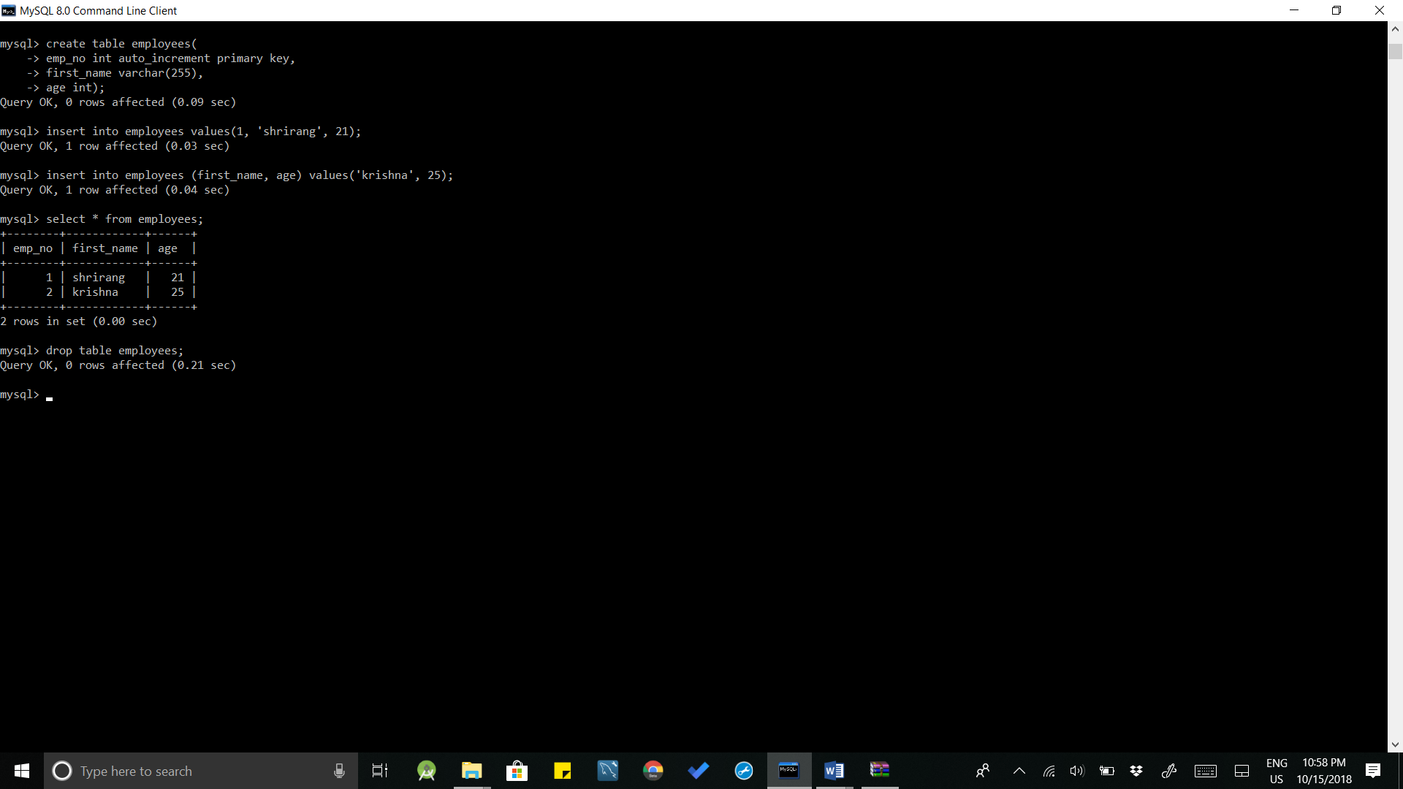

**Queries:**

1. Create table employees(emp_no, int auto_increment, primary key, first_name varchar(255), age int);
2. Insert into employees values(1, ‘shrirang’, 21);
3. Insert into employees (first_name, age) values (‘krishna’, 25);
4. Select * from employees;
5. Drop table employees;

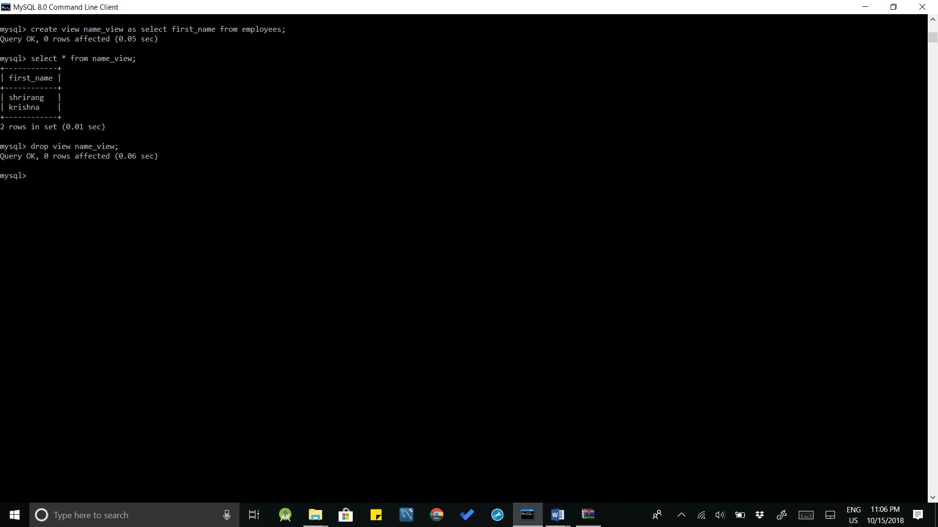

**Queries:**

1. Create view name_view as select first_name from employees;
2. Select * from name_view;
3. Drop view name_view;

**Conclusion:** SQL DDL statements which demonstrate the use of SQL objects such as Table, View, Index, Sequence, Synonym were successfully implemented.